**BEAMFORMING FOR V2V COMMUNICATION UTILIZING DEEP LEARNING**

Ramana Srivats1, Aravindan SM2, Shri Harish3, Mrs. Kasthuri4 and Dr. P.Prakash5

1 Anna University, Chennai, India

2 Anna University, Chennai, India

3 Anna University, Chennai, India

**Abstract**

Vehicle-to-Vehicle (V2V) communication systems hold significant promise for enhancing road safety and efficiency. In this work, we used an existing dataset comprising GPS latitude and longitude coordinates and corresponding ideal beam which gives least power loss to train a machine learning model. By extracting features such as inter-vehicle distance and angle of arrival from the dataset, we trained six machine learning models to predict vehicle interactions and calculated the top-k accuracy and average power loss. Our analysis revealed that Random Forest emerged as the most accurate model with 85.37% top-5 accuracy and -1.45db average power loss, showcasing its efficiency even when the data is unbalanced. XGBoost and Decision Tree models also performed well with 74.77% and 74.9% respectively. These findings imply the potential of machine learning in optimizing V2V communication systems for safer and more efficient road networks.

**Keywords:** Vehicle-to-vehicle, Decision Tree, Beam Forming, Lidar, Angle of Arrival

1. Introduction

Vehicle-to-Vehicle (V2V) communication represents a pivotal advancement in both transportation and telecommunication realms. It facilitates direct interaction among vehicles on the road, enabling the real-time exchange of crucial information without relying heavily on infrastructure-based systems. This technology enhances road safety, optimizing traffic flow, and ushering in a new era of intelligent transportation systems. Data sharing in V2V communication plays a crucial role in facilitating efficient and safe navigation on the roads. It involves the exchange of various types of data among vehicles engaged in V2V communication. This data encompasses critical information such as speed, position, acceleration, and other relevant factors. Such data is collected in real-time through onboard sensors like GPS, radar, and LiDAR, which are equipped in modern vehicles The applications enabled by V2V communication are diverse and impactful. They encompass functionalities like cooperative adaptive cruise control, intersection collision warning, and emergency vehicle notification, among others. These applications play a pivotal role in improving road safety, optimizing traffic management, and enhancing the overall efficiency of transportation networks. Significant efforts have been dedicated to improving beamforming efficiency in V2V communication systems through the integration of position-related 2 information. Advanced methodologies, including machine learning and deep learning techniques, have been extensively explored to optimize beamforming processes and mitigate complexity. These initiatives are driven by the objective of maximizing the efficacy and reliability of V2V communication systems in practical, real-world scenarios. By harnessing sophisticated algorithms and leveraging spatial data, researchers aim to enhance the precision and speed of beamforming operations, ultimately contributing to the seamless exchange of information among connected vehicles. The DeepSense 6G dataset [1] is a collection of real-world scenarios that includes multi-modal sensing and communication data. The dataset is intended to help advance deep learning research in a variety of applications that combine multimodal sensing, communication, and positioning.

The central contribution of this paper lies in introducing a machine learning model to predict optimal beam V2V communication system using 6 models which are ANN, SVM, KNN, Random Forest, XGBoost and Decision Tree. By using machine learning model we get better predictions compared baseline solution.

1. Related Works

Mollah et al. (2024) [21] proposed a position-aware beamforming strategy for 60 GHz millimeter-wave (mmWave) V2V communication. This method utilized the spatial and temporal positions of vehicles to predict the optimal beam angles, enhancing the communication link's reliability. Their approach demonstrated improved performance in high mobility scenarios but required precise position data, which may not always be available in real-time applications.

Another significant contribution by Wang et al. (2023) [3] introduced a deep learning-based beam selection framework for V2V communication. They employed convolutional neural networks (CNNs) to process vehicle position data and environmental information, predicting the best beamforming vectors. Their model achieved high accuracy in urban environments with dense obstacles but faced challenges in less structured rural areas where environmental features were sparse.

Gao and Huang (2022) [20] focused on reinforcement learning (RL) techniques for adaptive beamforming in dynamic V2V networks. Their RL-based model learned optimal beamforming policies through continuous interaction with the environment, adapting to changing network conditions. While this method showed promise in dynamically changing environments, the training process was computationally intensive and required significant time to converge.

In addition to deep learning and RL approaches, traditional machine learning models have also been investigated for beamforming in V2V communication. Liu et al. (2021) [11] applied support vector machines (SVM) and k-nearest neighbors (KNN) to predict beamforming parameters based on historical communication data. Their study highlighted the effectiveness of these models in static scenarios but noted a decline in performance under high mobility conditions.

Despite these advancements, there remains a gap in leveraging comprehensive GPS data for real-time beamforming optimization in V2V communication. Existing studies often rely on partial or indirect data, limiting their applicability in practical scenarios. This research aims to fill this gap by using detailed GPS data to train machine learning models, specifically focusing on features like the distance between vehicles and angle of arrival, to predict optimal beams with high accuracy and minimal power loss.

Our study differentiates itself by comparing multiple machine learning models, including artificial neural networks (ANN), random forest, and decision trees, to identify the most effective approach for real-time beamforming in V2V communication. By evaluating these models based on Top-5 accuracy and average power loss, we aim to provide a comprehensive analysis of their performance, offering valuable insights for future developments in this field.

1. DeepSense 6G dataset

The DeepSense 6G dataset [1] is a collection of real-world scenarios that includes multi-modal sensing and communication data. The dataset is intended to help advance deep learning research in a variety of applications that combine multimodal sensing, communication, and positioning. Each scenario in the DeepSense 6G dataset is a standalone dataset that's created from a single, usually lengthy, data collection session. The data is formatted in a generic way that's consistent across all scenarios. The data collection for each scenario is intended to cover a significant deployment scenario and enable one or more applications. In this work scenario 36-39 has been used.

Scenarios 36 and 38 are collected in an outdoor wireless environment and are explicitly designed to study high-frequency V2V communication in the real world. The dataset is collected using DeepSense. The testbed comprises two units: Unit 1, a mobile receiver (vehicle) equipped with advanced sensing capabilities, and Unit 2, a mobile transmitter. 10 Scenarios 36 and 37 are collected in long drives between cities, targeting long travels, and are referred to as inter-city scenarios. Scenarios 38 and 39 are predominantly focused on emulating short urban commutes, capturing data primarily within city boundaries. The distinction between these scenarios is supported by the variations in traveled distances and average speeds of the vehicles. Scenarios 36 involve traveling long distances at relatively high average speeds, while Scenarios 38 covers shorter distances at lower speeds due to speed limits imposed within cities. Figure 3.1 shows the visual representation of the scenarios.

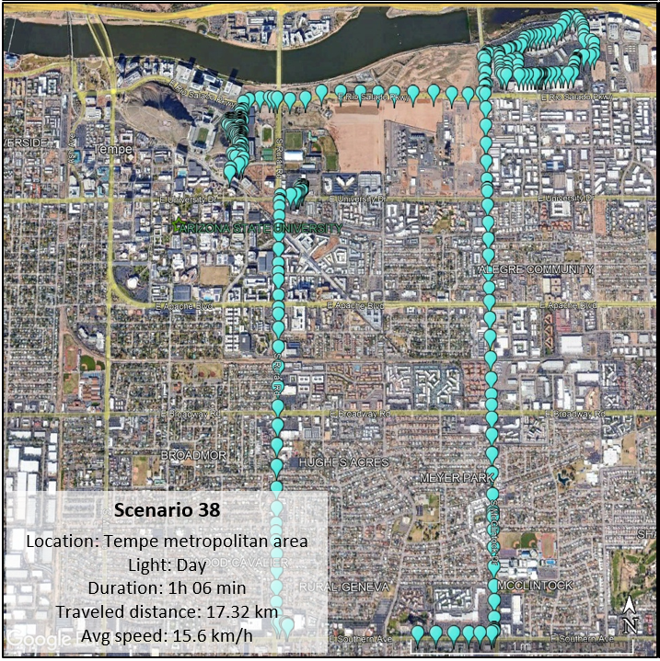 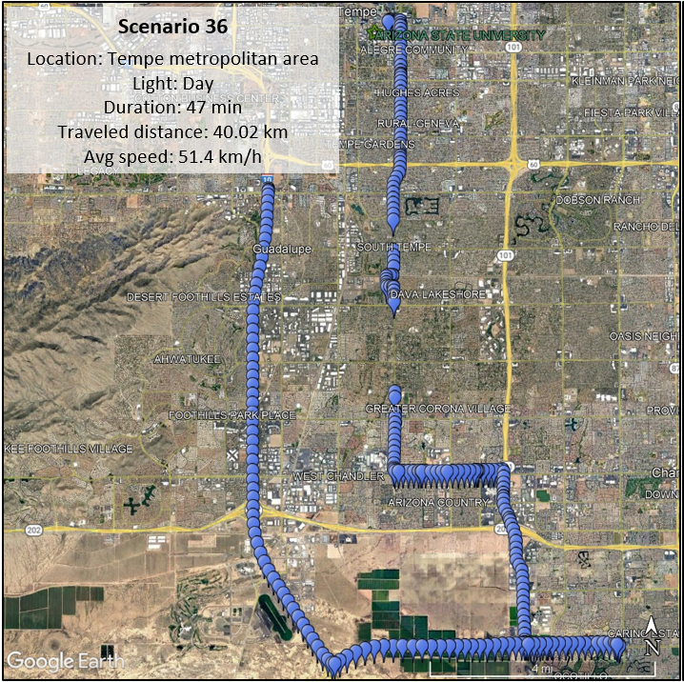

1. Scenario 38 (b) Scenario 36

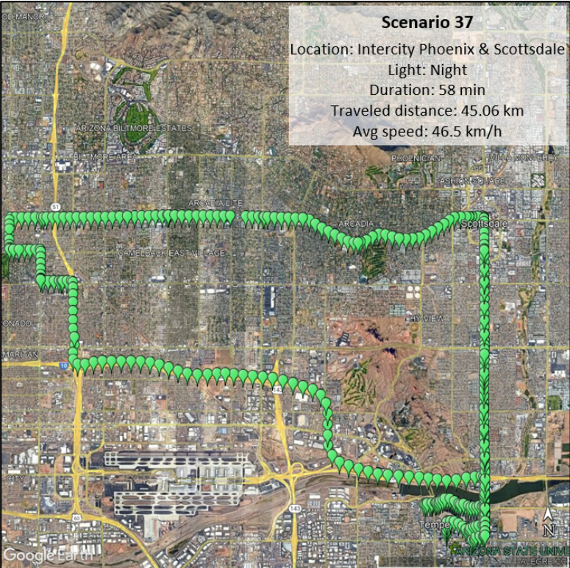

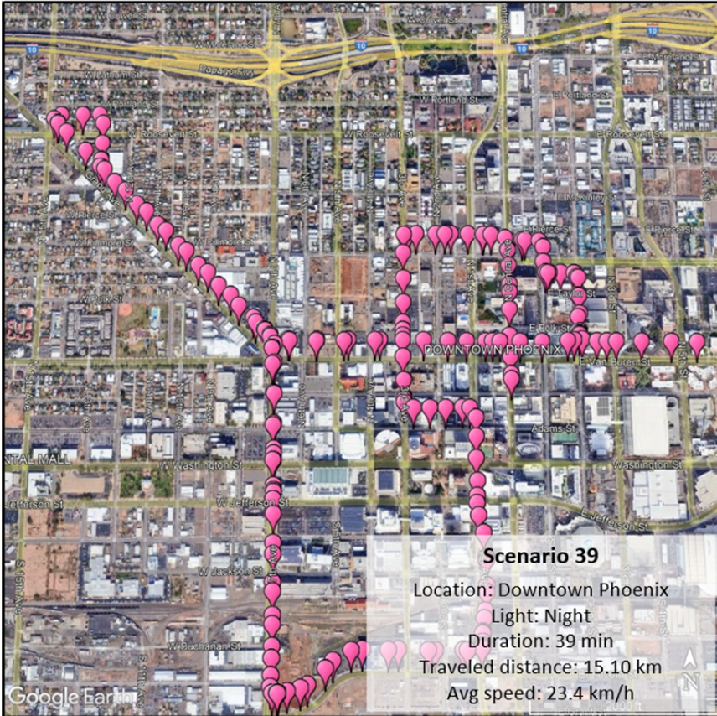

(c) Scenario 39 (d)Scenario 37

**Figure 3.1. DeepSense 6G scenarios**

1. Feature Extraction

To effectively train our models, we extracted relevant features from the dataset. The original dataset had features like altitude, vertical position and horizontal position apart from GPS position data and the corresponding optimal beam. We extracted more angular features for more efficient prediction.

* 1. Distance between Vehicles

The Euclidean distance between the GPS coordinates of the transmitting and receiving vehicles. This feature helps in understanding the signal path and potential obstacles. This is calculated using havesine function. The haversine function hav(θ), applied above to both the central angle θ and the differences in latitude and longitude, is

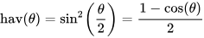 (1)

The haversine function computes half a versine of the angle θ, or the squares of half chord of the angle on a unit circle (sphere). To solve for the distance d, apply the archaversine (invers haversine) to h = hav(θ) or use the arcsine (inverse sine) function:

 (2)

* 1. Angle of Arrival (AoA)

The angle at which the signal arrives at the receiving vehicle. This is crucial for determining the optimal beam direction. AoA is estimated using the relative position of the 2 cars. We also calculate the AoA of previous time sample and then calculate the rate of change of aoa between the two cars.

* 1. Velocity

The relative speed between the two vehicles, calculated from their GPS coordinates over time. This feature helps in modeling dynamic scenarios where the positions of vehicles change rapidly. From the calculated distance we determine the velocity by subtracting the 5th sample from the future extrapolated position divided by 500ms since each data has 5 samples at 100ms interval.

1. Model Training

We implemented and trained six different machine learning models to predict the optimal beam and compared the performance using Top-k accuracy metrics and calculated average power loss for evaluation.

* 1. Artificial Neural Networks (ANN)

This neural network model follows a sequential architecture, comprising 3 densely connected layers.

The input layer consists of 1024 units with Rectified Linear Unit (ReLU) activation function, accepting input data of shape (6).

Subsequent hidden layers include:

1.A layer with 768 units, activated by ReLU.

2.Another layer with 512 units, also activated by ReLU.

3.A final hidden layer with 256 units, utilizing ReLU activation.

The output layer consists of 256 units, employing the softmax activation function to output probabilities for each class.

* 1. K-Nearest Neighbors (KNN)

The k-nearest neighbors (KNN) algorithm is a non-parametric, supervised learning classifier, which uses proximity to make classifications or predictions about the grouping of an individual data point.

It operates based on the principle that similar data points tend to belong to the same class or have similar output values. For a given data point, KNN identifies its K nearest neighbors in the feature space and assigns a class label or predicts a value based on the most common class label or average value among its neighbors.

The K-NN algorithm works by finding the K nearest neighbors to a given data point based on a distance metric, such as Euclidean distance. The class or value of the data point is then determined by the majority vote or average of the K neighbors. The configuration K is set to 5, considering the five nearest neighbors for prediction.

* 1. Support Vector Machine (SVM):

A support vector machine (SVM) is defined as a machine learning algorithm that uses supervised learning models to solve complex classification, regression, and outlier detection problems by performing optimal data transformations that determine boundaries between data points based on predefined classes, labels, or outputs.

The goal of the SVM algorithm is to create the best line or decision boundary that can segregate n-dimensional space into classes so that we can easily put the new data point in the correct category in the future. This best decision boundary is called a hyperplane.

The hyperplane tries that the margin between the closest points of different classes should be as maximum as possible. The dimension of the hyperplane depends upon the number of features. Here Radial Basis Function (RBF) kernel is used to handle non-linearity.

Regularization Parameter (C): Tuned to avoid overfitting.

* 1. Random Forest:

Random Forest is a powerful ensemble learning technique that enhances predictive accuracy by aggregating the outputs of multiple decision trees. It employs bootstrap sampling to create diverse subsets of the training data and introduces randomness by considering only a random subset of features at each split in each tree.

Through recursive construction, decision trees are built to maximize predictive performance, selecting the best features for splitting at each node. The final prediction is then determined by averaging (for regression) or voting (for classification) across all individual trees. Random Forest is prized for its robustness against overfitting and its ability to handle missing data. We use 50 decision trees to ensure robustness.

* 1. XGBoost:

XGBoost stands as a leading machine learning algorithm renowned for its exceptional performance in handling structured and tabular data across various predictive modeling tasks. XGBoost employs a gradient boosting framework, where decision trees are sequentially constructed to iteratively correct the errors of previous trees. This approach ensures superior predictive accuracy while mitigating overfitting through the integration of regularization techniques such as L1 and L2 regularization. With a large number of tunable hyperparameters, XGBoost facilitates meticulous model optimization, empowering users to achieve optimal performance across a wide array of machine learning applications. Here we use 50 gradient boosted trees. Learning rate is set to 0.1 for a balance between speed and accuracy. L1 and L2 regularization is used to prevent overfitting.

* 1. Decision Tree:

The decision tree model is a versatile and interpretable machine learning algorithm used for both classification and regression tasks. It operates by recursively partitioning the dataset into subsets based on feature values, forming a tree-like structure where each internal node represents a feature and a split point, while each leaf node represents a predicted class label or value. Decision trees also provide valuable insight into feature importance, aiding in feature selection and interpretation. Despite their simplicity, decision trees offer computational efficiency during both training and prediction, making them applicable to large datasets and real-time applications.

1. Computational Results

The Random Forest model achieved the highest Top-5 accuracy and the lowest average power loss, indicating its superior ability to predict optimal beams for V2V communication. The model's robustness to overfitting and capability to handle diverse features contributed to its performance.

XGBoost and Decision Tree models also performed well, with XGBoost offering a balance between accuracy and computational efficiency, while Decision Tree provided a simpler, faster alternative with respectable accuracy.

The ANN model showed promise in capturing complex patterns but required more computational power and time. KNN and SVM models, while effective in certain scenarios, were less suitable for the high-dimensional, dynamic nature of V2V communication data. We use Top-5 Accuracy metric which indicates the percentage of instances where the correct beam is within the top 5 predicted beams. It is particularly useful in scenarios where there are multiple potential optimal beams. Average Power Loss metric measures the difference in power between the predicted beam and the optimal beam. A lower average power loss indicates better performance in terms of signal strength and quality.

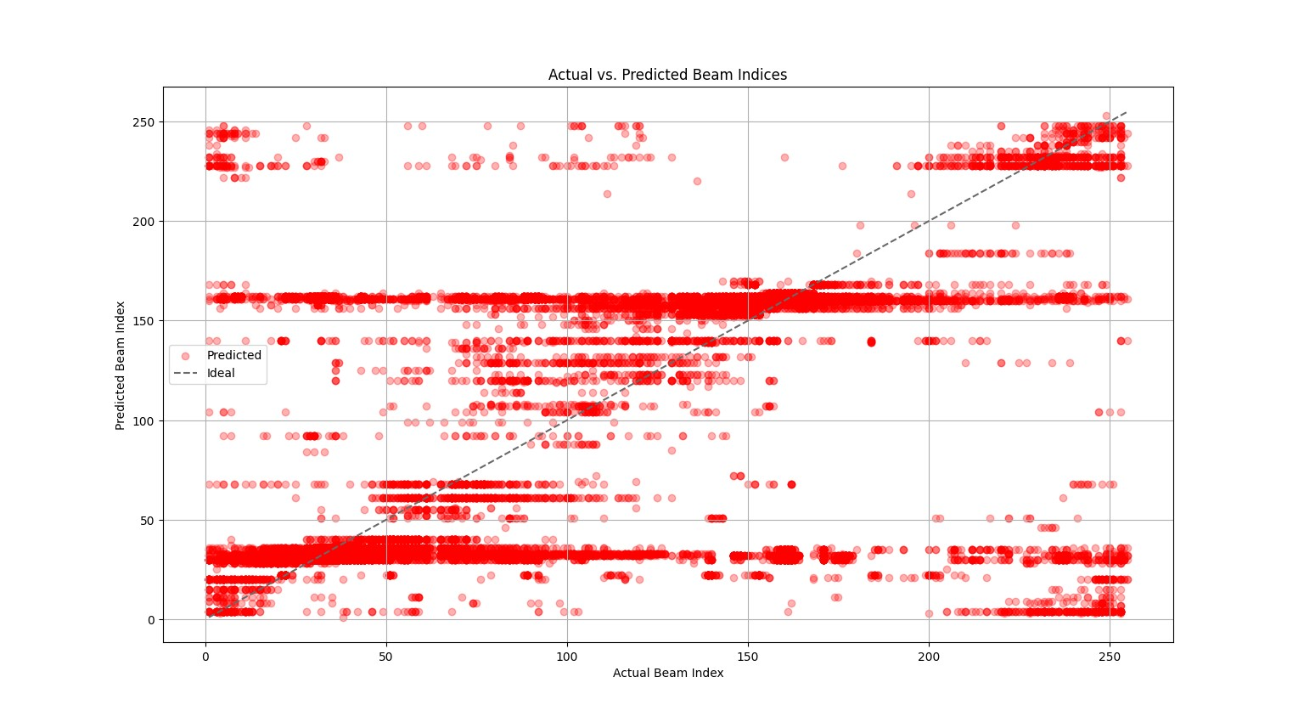

**Figure 6.1 Scatter Plot Of Actual Vs Predicted Values For ANN Model**

The scatter plot presented in Figure 6.1 showcases the performance evaluation of the ANN model, contrasting actual beam indices with their corresponding predicted values. Here, the red data points signify the model's predictions, while the dotted black line represents the true indices. As observed, there are noticeable deviations between actual and predicted values, particularly where points diverge significantly. These deviations may be attributed to various factors, including an imbalanced dataset where certain scenarios are underrepresented, leading to limitations in the model's predictive accuracy.

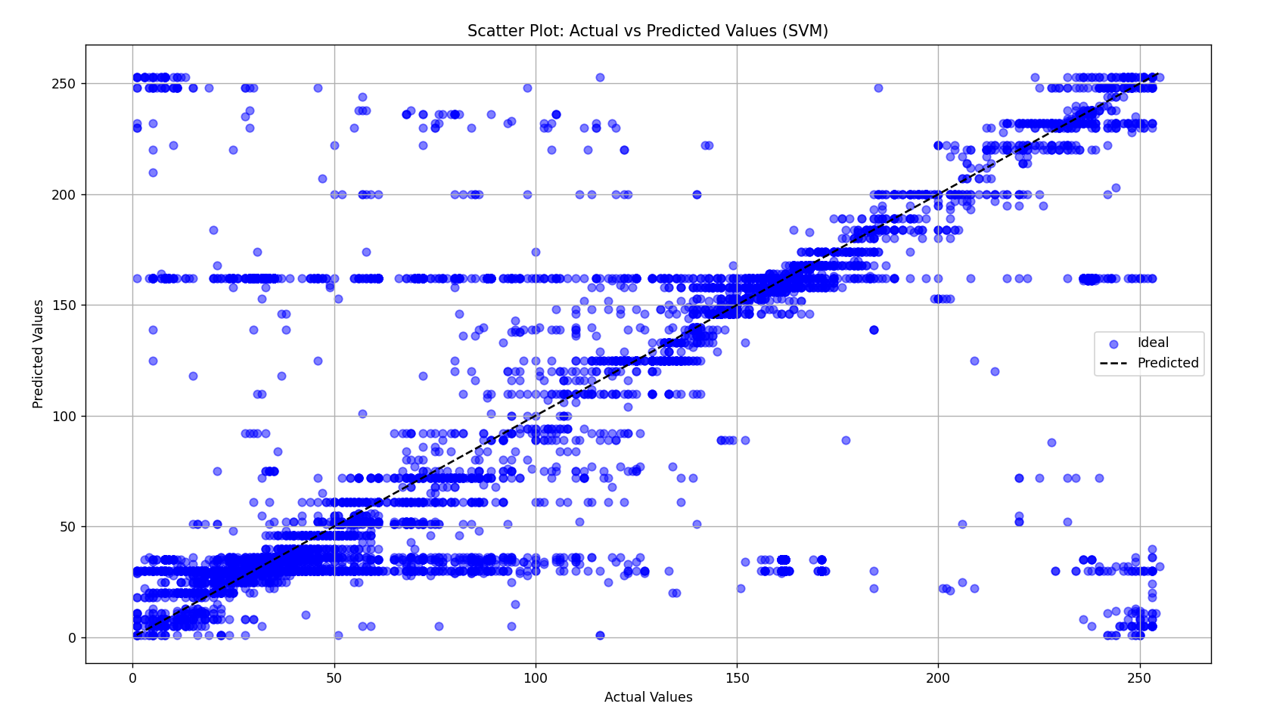

**Figure 6.2 Scatter Plot of Actual Vs Predicted Values for SVM Model**

The scatter plot depicted in Figure 6.2 illustrates the performance of the SVM model by showing actual and predicted beam indices. The blue data points correspond to the predicted values produced by the model, while the dotted black line represents the actual values. This visual comparison enables an assessment of the model's accuracy. However, discrepancies between actual and predicted values are observed, particularly in instances where points are significantly distant. These deviations may be attributed to an unbalanced dataset, where certain scenarios are underrepresented, leading to limitations in the model's predictive capabilities. Additionally, challenges arise in predicting beam indices during complex moving of the cars such as turning at junctions.

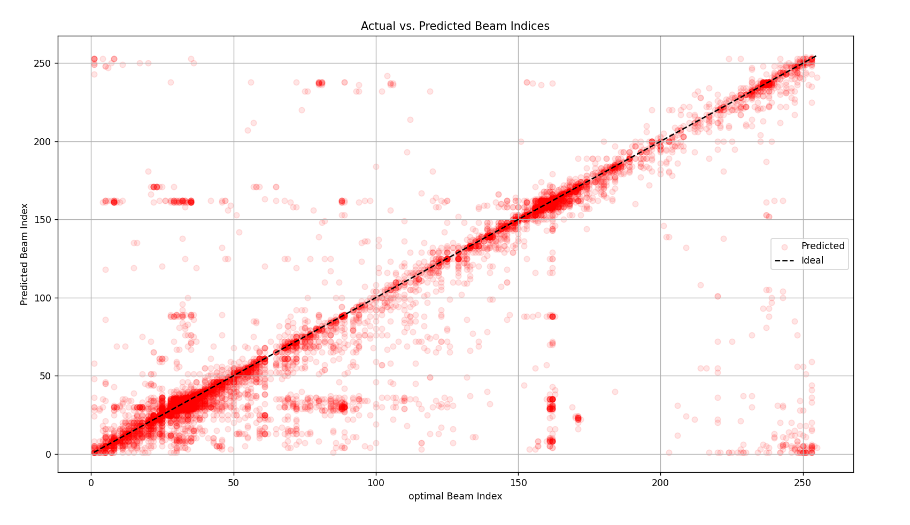

**Figure 6.3 Scatter Plot of Actual Vs Predicted Values for KNN Model**

The Scatter plot in figure 6.3 illustrates a comparison between the actual and predicted beam indices from a KNN model, which achieves higher accuracy compared to SVM and the ANN Models. Here, the red points represent the predicted values generated by the KNN model, while the dotted black line represents the actual values. Table 6.1 shows the top-k accuracy calculated for scenarios 36,37,38 and 39 all combined. As given by table 6.1 below this model gives a higher accuracy compared to KNN model. The top-k classification accuracy is one of the core metrics in machine learning. Here, k is conventionally a positive integer, such as 1 or 5, leading to top-1 or top-5 training objectives. This metric computes the number of times where the correct label is among the top k labels predicted (ranked by predicted scores).

**Table 6.1 Comparison of Top-K Accuracy for ANN, KNN and SVM**

|  |  |  |  |
| --- | --- | --- | --- |
| MODEL | Top-1(%) | Top-3(%) | Top-5(%) |
| Baseline | 14.27 | 37.84 | 52.96 |
| ANN MODEL | 17.21 | 36.12 | 52.01 |
| K-NEAREST NEIGHBORS | 33.73 | 58.96 | 68.95 |
| SUPPORT VECTOR MACHINE | 23.29 | 52.8 | 62.42 |

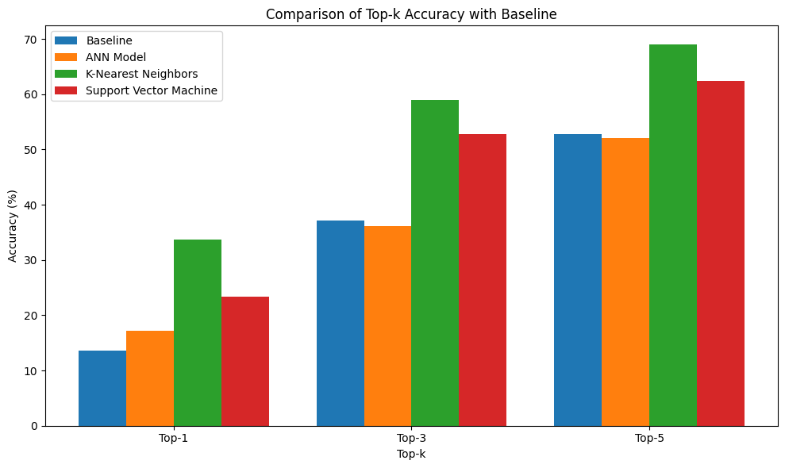

**Figure 6.4 Top-K Accuracies for Different ML Models Against Baseline Model**

As shown 6.4 in the bar graph in figure the K-Nearest Neighbors (KNN) model consistently demonstrates superior performance compared to the Artificial Neural Network (ANN) and Support Vector Machine (SVM) models. With an accuracy of 33.73, 58.96 and 68.95 in predicting the optimal beam index within the top 1, top 3, and top 5 respectively, the KNN algorithm establishes itself as the most reliable choice for all scenarios combined. This unified outcome underscores the effectiveness of the KNN model across varied scenarios, reaffirming its efficacy in beam index prediction tasks.

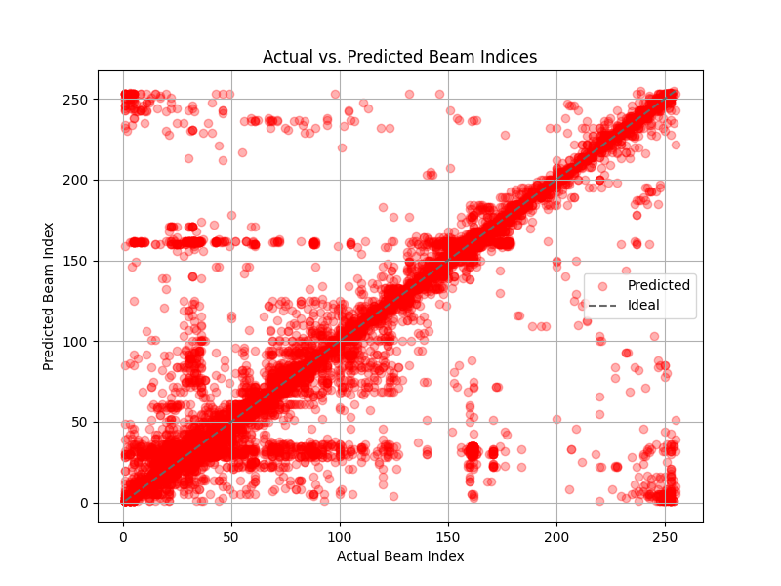

**Figure 6.5 Scatter Plot of Actual Vs Predicted Values For Random Forest**

The figure 6.5 represents the scatter plot for the predicted vs the actual beam indices for the random forest model. As shown this model attains higher accuracy compared to the previous model and this model performs optimally in 37 the case where the data is unbalanced. Table 6.2 represents the top-k accuracy and average power loss for each scenario and then all the scenarios combined. In combined we concatenate all the four scenarios and split it into train and test. This diversifies the training data and makes the model more generic and efficient. In scenario 37 and 39 the model performs very well with 93.62 and 93.53 percent accuracy.

# TABLE 6.2 Random Forest Top-K Comparision for All Scenarios

|  |  |  |  |  |
| --- | --- | --- | --- | --- |
| Scenario | TOP1(%) | TOP3(%) | TOP5(%) | Avg.power loss(db) |
| 36 | 58.83 | 84.68 | 88.49 | -0.77 |
| 37 | 55.38 | 88.65 | 93.62 | -0.45 |
| 38 | 43.26 | 73.65 | 82.42 | -1.78 |
| 39 | 49.16 | 85.99 | 93.53 | -0.67 |
| Combined(36,37,38,39) | 46.93 | 77.27 | 85.37 | -1.45 |

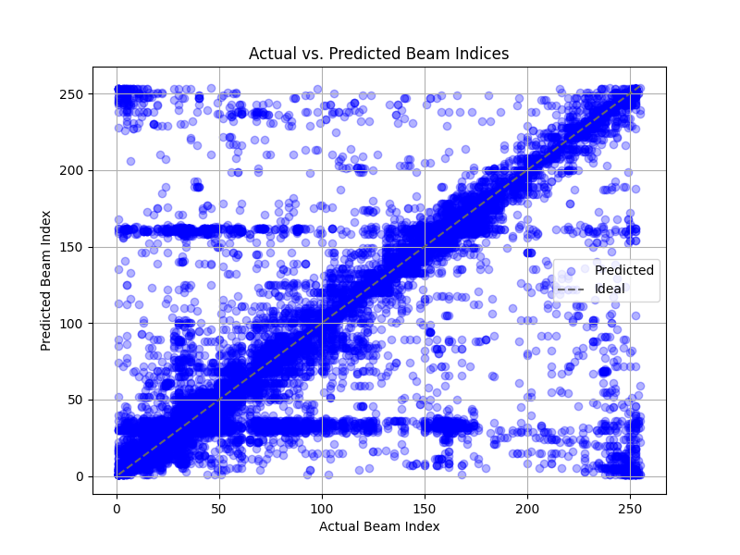

**Figure 6.6 XGBOOST MODEL SCATTER PLOT**

The figure 6.6 represents the scatter plot for the predicted vs the actual beam indices for the XGBoost model. As shown this model attains higher accuracy compared to the ANN, SVM and KNN model but lower compared to Random Forest Model. Table 6.3 represents the top-k accuracy and average power loss for each scenario and then all the scenarios combined.

# Table 6.3 Xgboost Top-K Comparision for All Scenarios

|  |  |  |  |  |
| --- | --- | --- | --- | --- |
| Scenario | TOP1(%) | TOP3(%) | TOP5(%) | Avg. power loss(db) |
| 36 | 48.21 | 75.67 | 80.98 | -2.24 |
| 37 | 43.6 | 77.76 | 85.34 | -1.69 |
| 38 | 34.95 | 62.62 | 72.46 | -3.24 |
| 39 | 43.68 | 80.92 | 90.69 | -1.13 |
| combined | 33.54 | 62.5 | 74.77 | -2.81 |

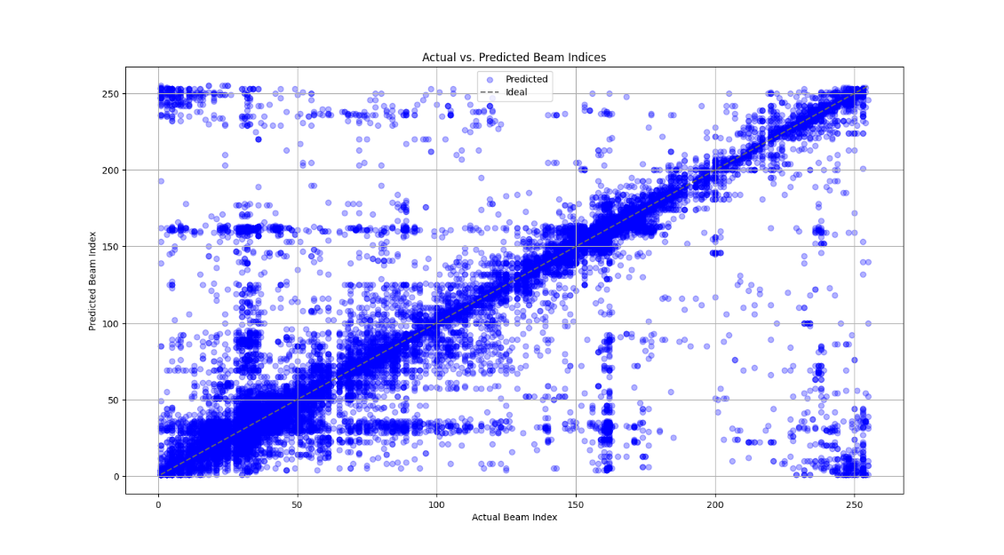

**Figure 6.7 Decision Tree Model Scatter Plot**

The figure 6.7 represents the scatter plot for the predicted vs the actual beam indices for the Decision Tree model. This model attains similar accuracy XGBoost Model and the points which are deviated away from the from the ideal straight line occurs when the car experiences turning at roads which are unpredictable at times. Table 6.4 represents the top-k accuracy and average power loss for each scenario and then all the scenarios combined for decision tree model.

# Table 6.4 Decision Tree Top-K Comparison For All Scenarios

|  |  |  |  |  |
| --- | --- | --- | --- | --- |
| Scenario | TOP1(%) | TOP3(%) | TOP5(%) | Avg. power loss(db) |
| 36 | 50.17 | 79.86 | 85.18 | -1.19 |
| 37 | 45.75 | 80.07 | 87.78 | -1.10 |
| 38 | 30.57 | 57.55 | 67.25 | -4.13 |
| 39 | 39.75 | 77.16 | 87.87 | -1.46 |
| Combined(36,37,38,39) | 35.27 | 64.52 | 74.9 | -2.82 |

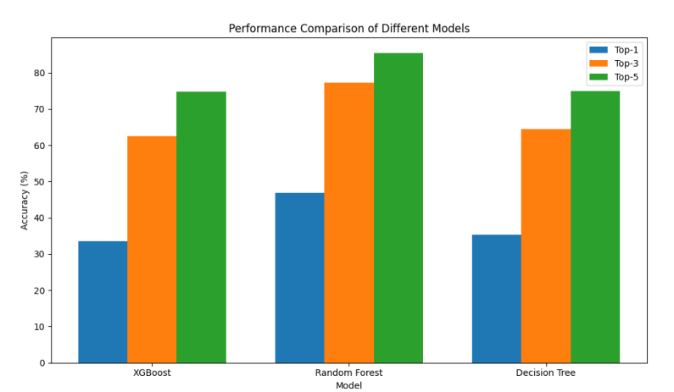

**Figure 6.8 Top-K Accuracy For Top Performing Ml Models**

The bar graph in figure 6.8 illustrates the performance of three models – Random Forest, XGBoost, and Decision Tree – in predicting the optimal beam index. Among these models, Random Forest exhibits the highest accuracy. This outcome is attributed to Random Forest's robustness in handling data imbalance, a common challenge in this predictive task. Despite variations in model 41 complexity and optimization techniques, Random Forest consistently outperforms XGBoost and Decision Tree in accurately identifying the optimal beam index. This highlights the importance of employing techniques that mitigate the effects of data imbalance when developing predictive models for similar tasks.

1. Conclusion

This project is focused on developing an efficient approach for predicting optimal beam configurations in Vehicle-to-Vehicle (V2V) communication systems, crucial for enhancing road safety and efficiency. Leveraging an existing dataset comprising GPS coordinates and corresponding optimal beams with minimal power loss, we trained six machine learning models—ANN, SVM, KNN, Random Forest, XGBoost, and Decision Tree. The models were trained using features such as inter-vehicle distance and angle of arrival which are extracted from the original dataset and the performance evaluation metric used was the top-k metric. Our analysis indicates Random Forest as the top-performing model, achieving a Top-5 accuracy of 85.37% and an average power loss of - 1.45dB. The model that performs the second best is the Decision Tree model, exhibiting a Top-5 accuracy of 74.9% with an average power loss of -2.82dB. These different models have been tested in different scenarios such as interstate and intercity scenarios where the distance travelled and speed of the cars vary. Thus, Random Forest stands out for its higher accuracy and power loss reduction, while the Decision Tree model is a good alternative with lower computational complexity. Thus, by leveraging machine learning—specifically Random Forest—we efficiently forecast optimal beams, mitigating training overhead and latency associated with traditional methods.

The experiments demonstrated that tree-based models, particularly Random Forest, are highly effective for optimizing beamforming in V2V communication. These models provide a robust solution for real-time applications, balancing accuracy and computational efficiency. Future research could explore further tuning of hyperparameters and integrating additional features to enhance performance.

This research contributes to the growing body of knowledge on optimizing V2V communication using machine learning. By demonstrating the effectiveness of the Random Forest model and providing a comparative analysis of various approaches, we offer valuable insights for future developments in this field. The findings highlight the potential of machine learning to revolutionize beamforming techniques, paving the way for more efficient and reliable V2V communication systems.

Reference

[1] Muhammad Baqer Mollah, Honggang Wang, and Hua Fang, "mmWave enabled connected autonomous vehicles: A use case with V2V cooperative perception," IEEE Network, pp. 1–7, 2023.

[2] G. Ciaramitaro, M. Brambilla, M. Nicoli, and U. Spagnolini, "Signalling design in sensor-assisted mmWave communications for cooperative driving," IEEE Open Journal of Intelligent Transportation Systems, 2023.

[3] H. Ngo, H. Fang, and H. Wang, "Cooperative perception with V2V communication for autonomous vehicles," IEEE Transactions on Vehicular Technology, 2023.

[4] "Propagation models and performance evaluation for 5G millimeterwave bands," IEEE Transactions on Vehicular Technology, vol. 67, no. 9, pp. 8422–8439, 2018.

[5] P. Kyöst, P. Zhang, A. Pärssinen, K. Haneda, P. Koivumäki, and W. Fan, "On the feasibility of out-of-band spatial channel information for millimeter-wave beam search," IEEE Transactions on Antennas and Propagation, 2023.

[6] Muhammad Alrabeiah and Ahmed Alkhateeb, "Deep learning for mmwave beam and blockage prediction using sub-6 GHz channels," IEEE Transactions on Communications, vol. 68, no. 9, pp. 5504–5518, 2020.

[7] A. Graff, Y. Chen, N. González-Prelcic, and T. Shimizu, "Deep learning-based link configuration for radar-aided multiuser mmwave vehicle-to-infrastructure communication," IEEE Transactions on Vehicular Technology, 2023.

[8] H. Luo, U. Demirhan, and A. Alkhateeb, "Millimeter wave V2V beam tracking using radar: Algorithms and real-world demonstration," arXiv preprint arXiv:2308.01558, 2023.

[9] U. Demirhan and A. Alkhateeb, "Radar aided 6G beam prediction: Deep learning algorithms and real-world demonstration," in 2022 IEEE Wireless Communications and Networking Conference (WCNC). IEEE, 2022, pp. 2655–2660.

[10] J. Gu, L. Collins, D. Roy, A. Mokhtari, S. Shakkottai, and K. R. Chowdhury, "Meta-learning for image-guided millimeter-wave beam selection in unseen environments," in ICASSP 2023-2023 IEEE International Conference on Acoustics, Speech and Signal Processing (ICASSP). IEEE, 2023, pp. 1–5.

[11] J. A. Zhang, F. Liu, C. Masouros, R. W. Heath, Z. Feng, L. Zheng, and A. Petropulu, “An overview of signal processing techniques for joint communication and radar sensing,” IEEE Journal of Selected Topics in Signal Processing, vol. 15, no. 6, pp. 1295–1315, 2021.

[12] F. Liu, Y. Cui, C. Masouros, J. Xu, T. X. Han, Y. C. Eldar, and S. Buzzi, “Integrated sensing and communications: Toward dual-functional wireless networks for 6g and beyond,” IEEE Journal on Selected Areas in Communications, vol. 40, no. 6, pp. 1728–1767, 2022.

[13] A. Liu, Z. Huang, M. Li, Y. Wan, W. Li, T. X. Han, C. Liu, R. Du, D. K. P. Tan, J. Lu, Y. Shen, F. Colone, and K. Chetty, “A survey on fundamental limits of integrated sensing and communication,” IEEE Communications Surveys and Tutorials, vol. 24, no. 2, pp. 994–1034, 2022.

[14] G. Charan, M. Alrabeiah, and A. Alkhateeb, “Vision-aided 6g wireless communications: Blockage prediction and proactive handoff,” IEEE Transactions on Vehicular Technology, vol. 70, no. 10, pp. 1019310208, 2021.

[15] M. Zecchin, M. B. Mashhadi, M. Jankowski, D. Gündüz, M. Kountouris, and D. Gesbert, “Lidar and position-aided mmwave beam selection with non-local cnns and curriculum training,” IEEE Transactions on Vehicular Technology, vol. 71, no. 3, pp. 2979–2990, 2022.

[16] G. Charan, U. Demirhan, J. Morais, A. Behboodi, H. Pezeshki, and A. Alkhateeb, “Multi-modal beam prediction challenge 2022: Towards generalization,” 2022. [Online]. Available: https://arxiv.org/abs/2209. 07519

[17] U. Demirhan and A. Alkhateeb, “Radar aided 6g beam prediction: Deep learning algorithms and real-world demonstration,” in 2022 IEEE Wireless Communications and Networking Conference (WCNC), 2022, pp. 2655–2660.

[18] S. Jiang, G. Charan, and A. Alkhateeb, “Lidar aided future beam prediction in real-world millimeter wave v2i communications,” IEEE Wireless Communications Letters, pp. 1–1, 2022.

[19] A. Ali, N. González-Prelcic, and A. Ghosh, “Passive radar at the roadside unit to configure millimeter wave vehicle-to-infrastructure links,” IEEE Trans. Veh. Technol., vol. 69, no. 12, pp. 14903–14917, 2020.

[20] H. Kim, K. Granström, L. Gao, G. Battistelli, S. Kim, and H. Wymeersch, “5g mmwave cooperative positioning and mapping using multimodel phd filter and map fusion,” IEEE Transactions on Wireless Communications, vol. 19, no. 6, pp. 3782–3795, 2020.

[21] Muhammad Baqer Mollah, Honggang Wang, Hua Fang" Position Aware 60 GHz mmWave Beamforming for V2V Communications Utilizing Deep Learning" arXiv preprint arXiv:2402.01259, 2024.